NGENO KIBET CALEB
SCT221-C004-0755/2017
ICS 2203: WEB APPLICATION DEVELOPMENT 1
ASSIGNMENT
- Steps to developing an ecommerce website
- Requirements
Establishing goal and purpose - setting up an e-commerce website for selling
cookware and kitchen accessories, aimed at simplifying operations and reaching more customers.
Identifying a domain, web hosting (Truehost – shared and affordable) and associated budget for the whole project.
Identifying images of products catalog of the e-commerce website – specified cookware and kitchen accessories. (downloading publicly available noncopyrighted – Unsplash or by taking photos on phone)
- Specification
Tools and resources identified – PHP, MySQL, me as sole developer.
Acquiring the domain.
Accepted payments from customer – card and mobile money.
Identifying product images – good quality.
- Design
Develop mockups of the user interface, structure the database schema (products, categories, orders, customers), prepare a prototype of the website and present it to the company. Once approved, proceed to implementation.
Identifying features such as cart, offers banner, logo, footer and header.
- Development
Implementing – setting up environment for PHP and MySQL since we will be developing in VS Code and Xcode. Scripting in PHP. Streaming data to MySQL.
Integrating forms – checkout form implementation using POST method to capture customer details.
Use prepared statements to prevent SQL injection.
Integrating stripe API for customer payments.
Setting up the admin to add, edit and delete products, manage orders and customers.
- Integration
Testing - API calls such as POST, GET and DELETE, functional testing, user interface testing and website compatibility with different screen sizes.
Present to company stakeholders for feedback. Make amendments.
Deploying- codebase to company GitHub, to acquired domain(public).
Marketing- Advertising and pushing it to the public on social media.
Maintenance- Monitor performance, update products, and patch security issues.

b.

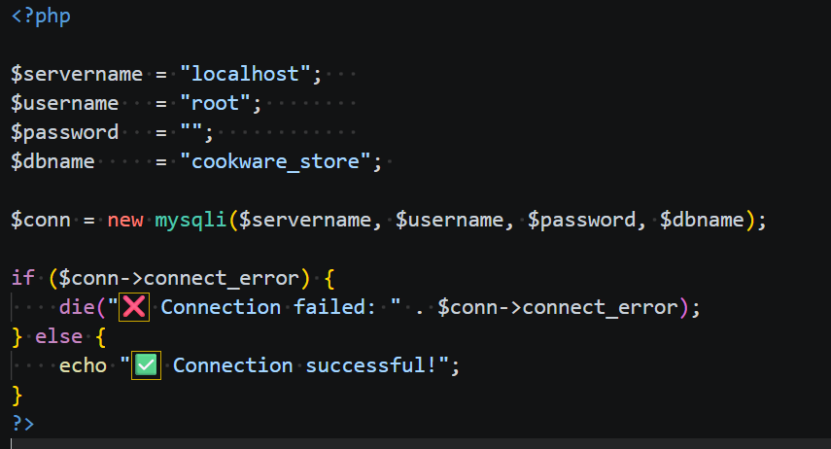
Successful
Close
End
Query
Start
Login

Error

Flowchart Diagram
Mr. Zan starts the process by adding connection parameters, He attempts to log in, he gets an error message if the log in details is wrong and is asked to login again with correct credentials, if they are right, he gets notified that attempt is successful. He can now access the database where he can run his queries. When he is done, he closes the system and that marks the end.
c. i) JavaScript brings interactivity to a webpage by fostering user actions, for instance, form submission. For example, checking if required fields of a form are filled.
ii) It enhances dynamic component set updates in a webpage by allowing developers to manipulate Document Object Model (DOM) elements without reloading, for instance, users adding event handlers like cart component in an ecommerce website. For instance, event listeners like button onclick.
iii) It improves user experience in a webpage by providing visual feedback or animations. Button or other user actions like clicks can be set to trigger. For instance, actions can be set such as timer or count.
iv) It allows for input validation as well as client-server communication by checking user input before it is sent to the server thus reducing overload and errors before submission. For instance, validating a login by checking for ‘@’ in email and password length and strength.

d) Cascading Style Sheets (CSS) in web design is utilized in giving color and style to web elements therefore fostering user experience in the user interface. It enhances presentation of web pages.

